Environment Setup Create a Flask Project

|  |  |
| --- | --- |
| Team ID | PNT2022TMID49745 |
| Project Name | Nutrition Assistant Application |

**Code:**

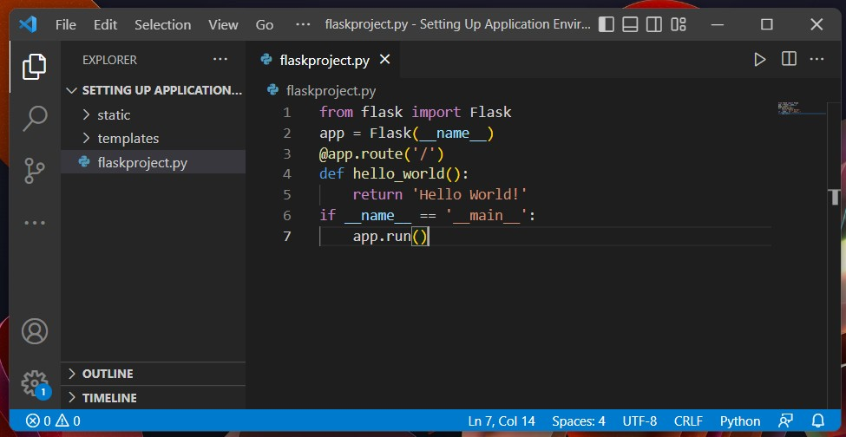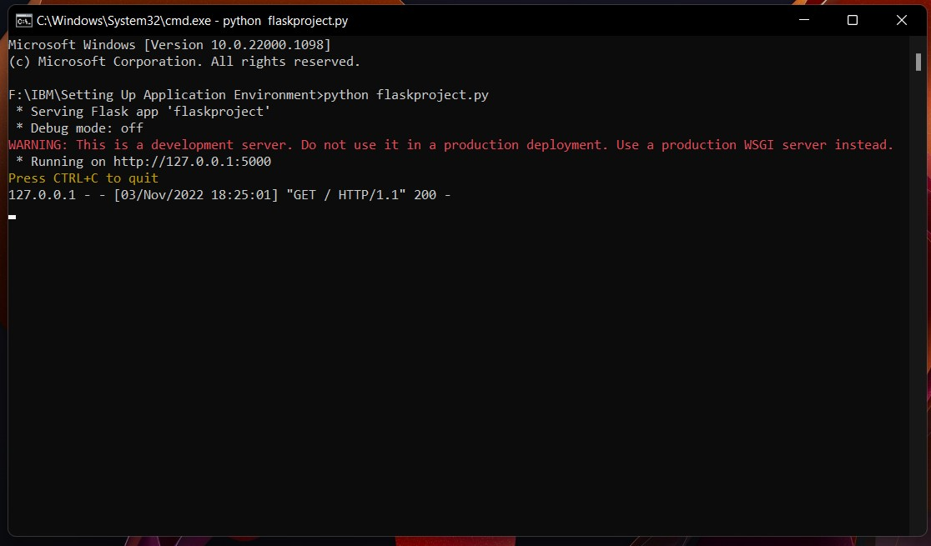

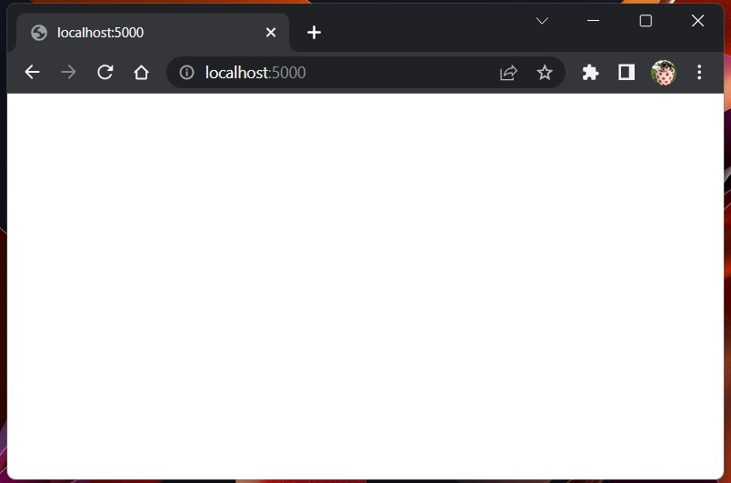

Hello World!